

Hand­s-on lab

Lab: Building an Adaptive UI

September 2015

Contents

Overview 3

Exercise 1: Transition to Adaptive UI 5

Task 1 – Create a blank Universal Windows app 5

Task 2 – Create a fixed layout 7

Task 2 – Adapt the layout for different screen sizes 9

Exercise 2: RelativePanels with Visual States 14

Task 1 – Add the RelativePanel 14

Exercise 3: Adaptive UI with XAML Views 19

Task 1 – Add a ScrollViewer to the Metadata panel 19

Task 2 – Create a XAML view 21

Summary 24

Overview

UWP apps fluidly transition between device families that may differ significantly in screen size and features. To accomplish this transition, the design must adapt to the device. An adaptive UI can detect information about the device it is running on and deliver a layout based on the characteristics of that device.

An adaptive UI differs from a responsive UI, because it can deliver an individualized layout for each device family or screen size snap point. A responsive UI typically takes a single, flexible design and displays it gracefully on all devices. One drawback to responsive UI can be a slower load time – elements are loaded for all devices and resolutions even though they may not ever be needed. With adaptive UI, you can deliver a responsive design, but you also have the ability to deliver unique views to devices that have little in common with each other. For example, an Xbox view may be completely distinct from the desktop and mobile views for an app, because the device UI and interactions are so different.

In this lab, we will evolve a fixed layout into an adaptive UI. Initially, the UI will follow more responsive practices. We will then create a separate view to handle a unique design element on Mobile.

# Objectives

* 1. This lab will show you how to:
  + Evolve a fixed layout into an adaptive UI
  + Create visual states to support narrow, medium, and wide screen widths
  + Use RelativePanel to reposition content in the different states
  + Use Setters to better adapt styles to a smaller screen
  + Use XAML views to create unique views for different device families

# System requirements

* 1. You must have the following to complete this lab:
  + Microsoft Windows 10
  + Microsoft Visual Studio 2015
  + Windows 10 Mobile Emulator

# Setup

* 1. You must perform the following steps to prepare your computer for this lab:
  2. Install Microsoft Windows 10.
  3. Install Microsoft Visual Studio 2015. Choose a custom install and ensure that the Universal Windows App Development Tools are selected from the optional features list.
  4. Install the Windows 10 Mobile Emulator.

# Exercises

* 1. This Hands-on lab includes the following exercises:
  2. Transition to Adaptive UI
  3. RelativePanels with Visual States
  4. Adaptive UI with XAML Views
  5. Estimated time to complete this lab:  **45 to 60 minutes**.

Exercise 1: Transition to Adaptive UI

* 1. When starting to build an app, creating a fixed layout can be an expedient shortcut. Fixed designs are not ideal for UWP apps, however, which may display on many different screens. In this exercise, you will create a simple fixed layout to display an image and its associated metadata. You will then evolve the fixed layout into an adaptive one.

Task 1 – Create a blank Universal Windows app

We will begin by creating a project from the Blank App template.

1. In a new instance of Visual Studio 2015, choose **File > New> Project** to open the New Project dialog. Navigate to **Installed > Templates > Visual C# > Windows > Universal** and select the **Blank App (Universal Windows)** template.
2. Name your project **AdaptiveUI** and select the file system location where you will save your Hands-on Lab solutions. We have created a folder in our **C:** directory called **HOL** that you will see referenced in screenshots throughout the labs.

Leave the options selected to **Create new solution** and **Create directory for solution**. You may deselect both **Add to source control** and **Show telemetry in the Windows Dev Center** if you don't wish to version your work or use Application Insights. Click **OK** to create the project.

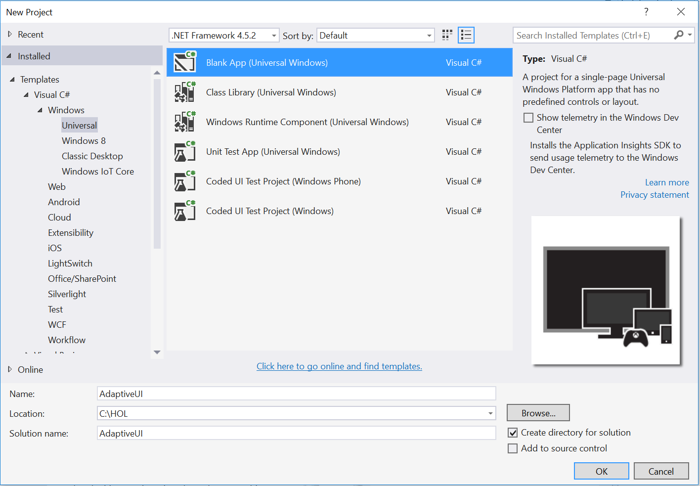

Figure 1

Create a new Blank App project in Visual Studio 2015.

1. Set your Solution Configuration to **Debug** and your Solution Platform to **x86**. Select **Local Machine** from the Debug Target dropdown menu.

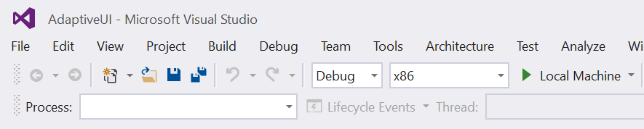

Figure 2

* + 1. Configure your app to run on the Local Machine.

1. Build and run your app. You will see a blank app window with the frame rate counter enabled by default for debugging.

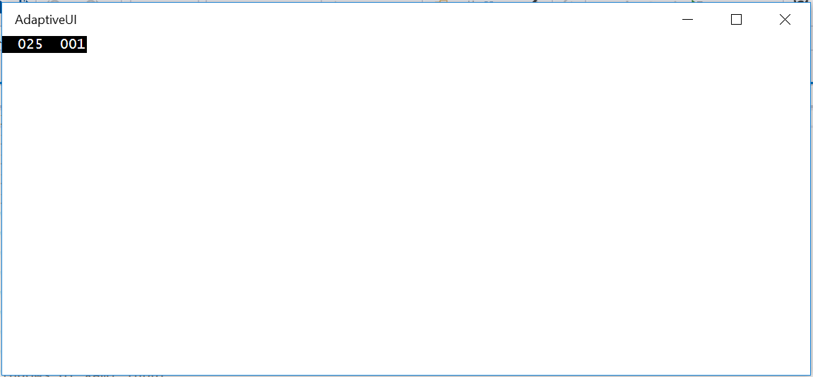

Figure 3

The blank universal app running in Desktop mode.

* 1. **Note:** The frame rate counter is a debug tool that helps to monitor the performance of your app. It is useful for apps that require intensive graphics processing but unnecessary for the simple apps you will be creating in the Hands-on Labs.
  2. In the Blank App template, the preprocessor directive to enable or disable the frame rate counter is in **App.xaml.cs**. The frame rate counter may overlap or hide your app content if you leave it on. For the purposes of the Hands-on Labs, you may turn it off by setting **this.DebugSettings.EnableFrameRateCounter** to **false**.

1. Return to Visual Studio and stop debugging.

Task 2 – Create a fixed layout

As a starting point, we will create a basic fixed layout containing simple content. The content will consist of a large image and its associated metadata: username, avatar, image name, date, and description. We will format the content into two columns.

1. Open **MainPage.xaml**. Add two **ColumnDefinitions** to the Grid with fixed widths of **500 epx**.
   * 1. XAML
   1. <Grid Background="{ThemeResource ApplicationPageBackgroundThemeBrush}">
   2. <Grid.ColumnDefinitions>
   3. <ColumnDefinition Width="500" />
   4. <ColumnDefinition Width="500" />
   5. </Grid.ColumnDefinitions>
   6. </Grid>
2. Right-click on the **Assets** folder and choose **Add > Existing Item**. Use the dialog to navigate to the **Win10HoL/Assets** folder and select **airtime.jpg** and **avatar.jpg**. Add them to your project.
3. Return to **MainPage.xaml**. Add the **airtime** image to the first column.
   * 1. XAML
   1. <Grid Background="{ThemeResource ApplicationPageBackgroundThemeBrush}">
   2. <Grid.ColumnDefinitions>
   3. <ColumnDefinition Width="500" />
   4. <ColumnDefinition Width="500" />
   5. </Grid.ColumnDefinitions>
   6. <Image Grid.Column="0" Source="Assets/airtime.jpg" Stretch="UniformToFill" />
   7. </Grid>
4. Add the avatar image and text metadata to the second column.
   * 1. XAML
   1. <Grid Background="{ThemeResource ApplicationPageBackgroundThemeBrush}">
   2. <Grid.ColumnDefinitions>
   3. <ColumnDefinition Width="500" />
   4. <ColumnDefinition Width="500" />
   5. </Grid.ColumnDefinitions>
   6. <Image Grid.Column="0" Source="Assets/airtime.jpg" Stretch="UniformToFill" />
   7. <StackPanel Grid.Column="1" Background="LightBlue">
   8. <Image Source="Assets/avatar.jpg" Width="100" Height="100" HorizontalAlignment="Left" />
   9. <TextBlock Text="phutureproof" />
   10. <TextBlock Foreground="White" FontSize="20" FontWeight="Light" Text="Airtime" />
   11. <TextBlock Text="9/15/15" />
   12. <TextBlock Text="Shot with a Canon DX8 at Washington Park in Los Angeles." />
   13. </StackPanel>
   14. </Grid>
5. Build and run your app. At certain aspect ratios, the content fits on the screen. Resize your window to see the behavior at smaller and larger window sizes. At smaller sizes, the second column is cut off, and at larger sizes, the content is surrounded by white space.

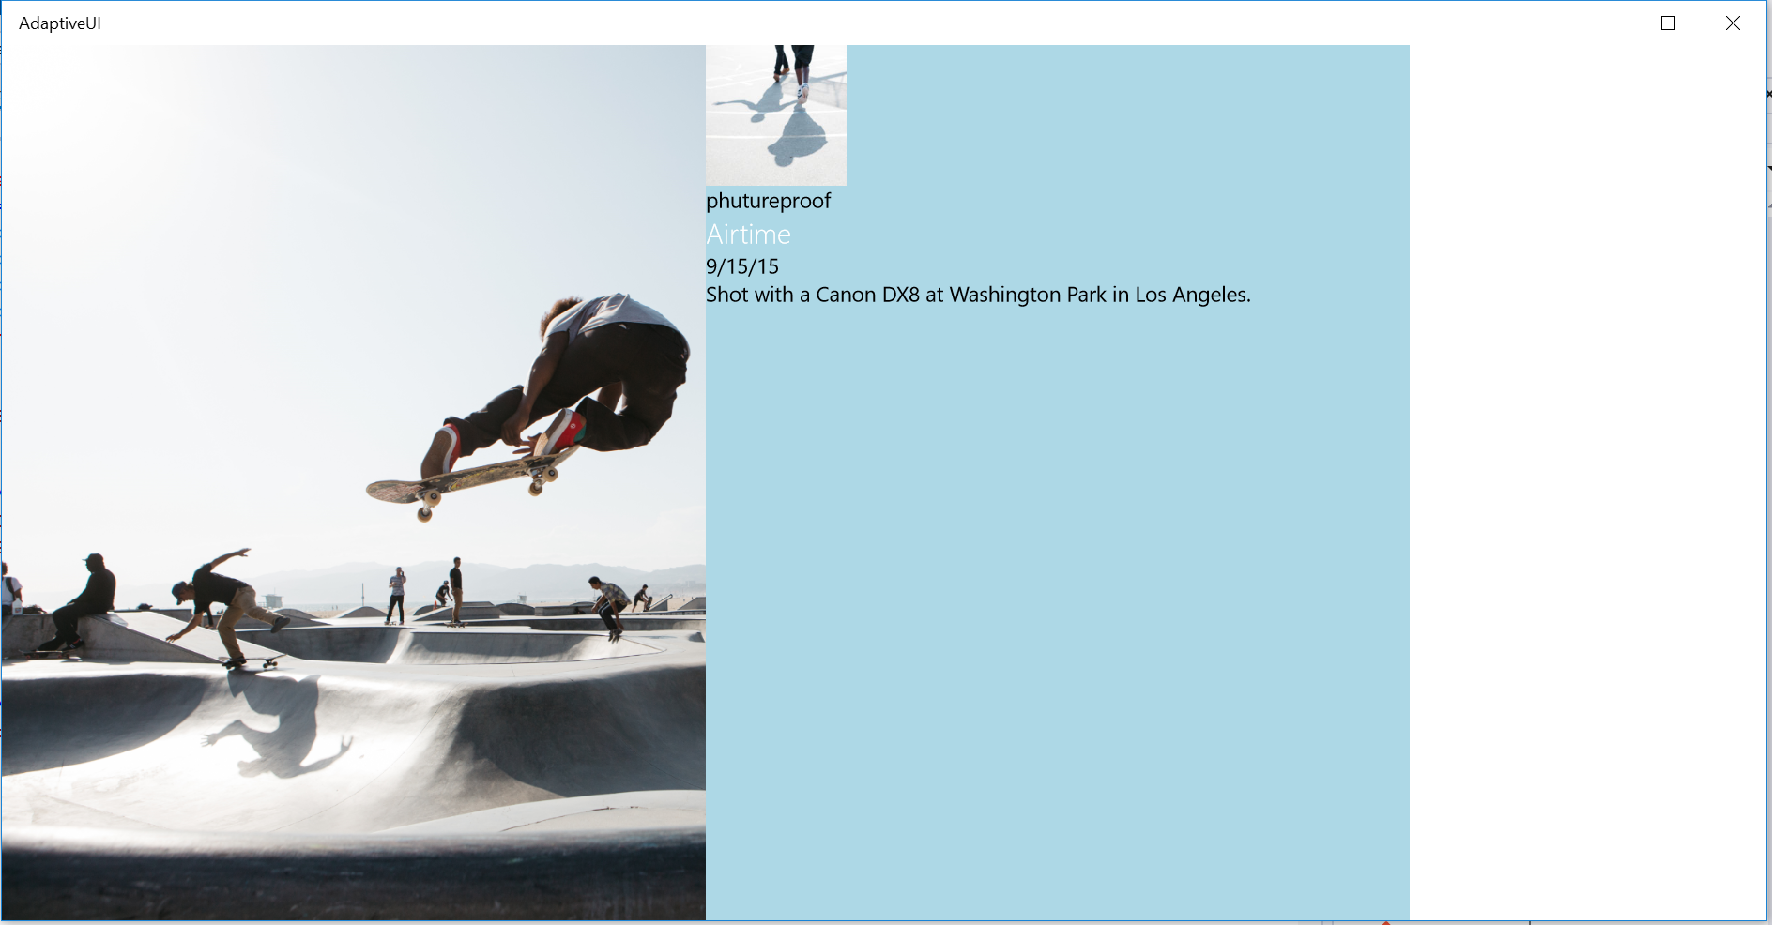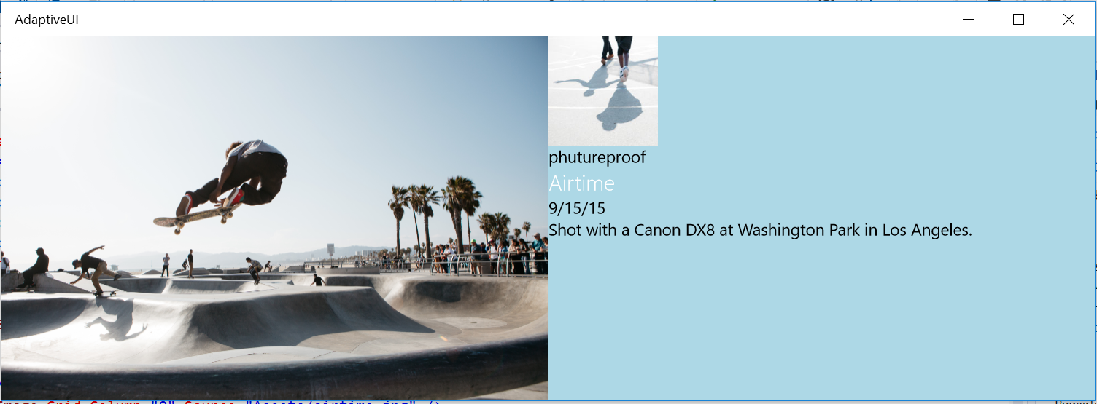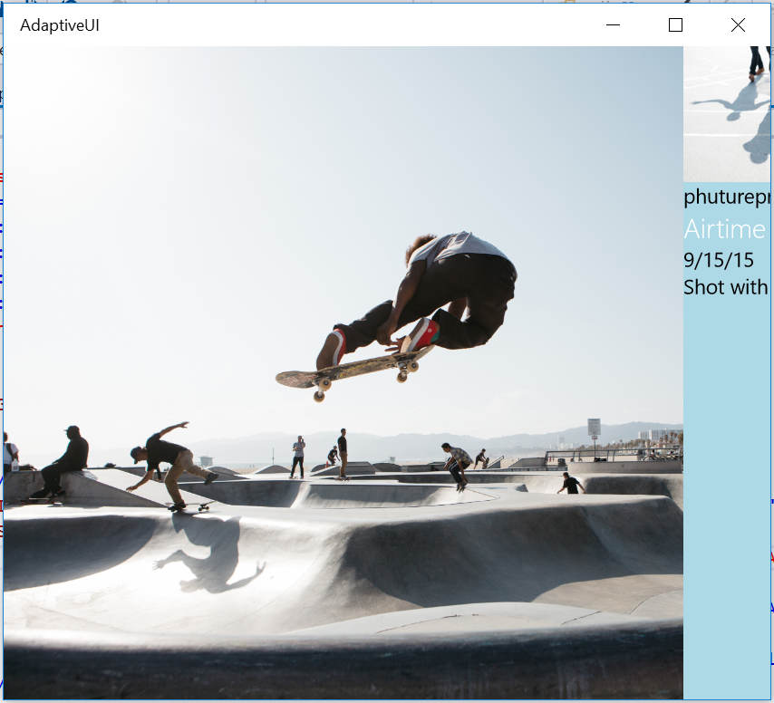

Figure 4

Fixed width columns at different window sizes.

1. Stop debugging and return to Visual Studio.

Task 2 – Adapt the layout for different screen sizes

Now that we’ve seen the drawbacks of a fixed layout UWP app, let’s make it adaptive. We will follow the six principles of responsive design: Reposition, Resize, Reflow, Reveal, Replace, and Re-architect.

* 1. **Note:** For more on responsive design in UWP apps, visit the Responsive Design 101 documentation at <https://msdn.microsoft.com/en-us/library/windows/apps/dn958435.aspx>

1. Add row definitions to the grid, and give the columns x:Name attributes. We will use rows and columns to reposition the content in the grid.
   * 1. XAML
   1. <Grid Background="{ThemeResource ApplicationPageBackgroundThemeBrush}">
   2. <Grid.RowDefinitions>
   3. <RowDefinition />
   4. <RowDefinition />
   5. </Grid.RowDefinitions>
   6. <Grid.ColumnDefinitions>
   7. <ColumnDefinition x:Name="LeftCol" />
   8. <ColumnDefinition x:Name="RightCol" />
   9. </Grid.ColumnDefinitions>
2. Add Visual States based on the **MinWindowWidth** adaptive trigger.
   * 1. XAML
   1. <Grid Background="{ThemeResource ApplicationPageBackgroundThemeBrush}">
   2. <VisualStateManager.VisualStateGroups>
   3. <VisualStateGroup x:Name="VisualStateGroup">
   4. <VisualState x:Name="VisualStateMin320">
   5. <VisualState.StateTriggers>
   6. <AdaptiveTrigger MinWindowWidth="320"/>

</VisualState.StateTriggers>

* 1. </VisualState>
  2. <VisualState x:Name="VisualStateMin548">
  3. <VisualState.StateTriggers>
  4. <AdaptiveTrigger MinWindowWidth="548"/>
  5. </VisualState.StateTriggers>
  6. </VisualState>
  7. <VisualState x:Name="VisualStateMin1024">
  8. <VisualState.StateTriggers>
  9. <AdaptiveTrigger MinWindowWidth="1024"/>
  10. </VisualState.StateTriggers>
  11. </VisualState>
  12. </VisualStateGroup>
  13. </VisualStateManager.VisualStateGroups>
  14. **Note:** Your UWP app will run on spectrum of screen sizes. Snap points are a helpful tool when targeting groups of devices with similar, but not identical, characteristics. Some recommended snap points are 320, 720, 1024 and 320, 548, 1024 depending on how your UI adapts through visual states. Adaptive triggers in UWP include both **MinWindowWidth** and **MinWindowHeight**. We will use the MinWindowWidth trigger in this exercise.

1. Give **x:Name** directives to the hero image and the metadata content, and assign the hero image to the first row and column of the grid. The hero image will remain in the first column and row regardless of visual state, so we can leave it as a static setting. The metadata content will move depending on the screen width, however. Remove the **Grid.Column** assignment from the **Metadata** StackPanel,
   * 1. XAML
   1. <Image x:Name="Hero" Grid.Column="0" Grid.Row="0" Source="Assets/airtime.jpg" Stretch="UniformToFill" />
   2. <StackPanel x:Name="Metadata" Background="LightBlue">
2. Add visual state setters to change the column behavior. For now, the two smaller visual states will share the same rules. We will differentiate them in the next exercise.
   * 1. XAML
   1. <VisualState x:Name="VisualStateMin320">
   2. <VisualState.StateTriggers>
   3. <AdaptiveTrigger MinWindowWidth="320"/>

</VisualState.StateTriggers>

* 1. <VisualState.Setters>
  2. <Setter Target="Hero.(Grid.ColumnSpan)" Value="2" />
  3. <Setter Target="Hero.(Grid.RowSpan)" Value="1" />
  4. <Setter Target="Metadata.(Grid.Column)" Value="0" />
  5. <Setter Target="Metadata.(Grid.Row)" Value="1" />
  6. <Setter Target="Metadata.(Grid.ColumnSpan)" Value="2" />
  7. <Setter Target="Metadata.(Grid.RowSpan)" Value="1" />
  8. </VisualState.Setters>
  9. </VisualState>
  10. <VisualState x:Name="VisualStateMin548">
  11. <VisualState.StateTriggers>
  12. <AdaptiveTrigger MinWindowWidth="548"/>
  13. </VisualState.StateTriggers>
  14. <VisualState.Setters>
  15. <Setter Target="Hero.(Grid.ColumnSpan)" Value="2" />
  16. <Setter Target="Hero.(Grid.RowSpan)" Value="1" />
  17. <Setter Target="Metadata.(Grid.Column)" Value="0" />
  18. <Setter Target="Metadata.(Grid.Row)" Value="1" />
  19. <Setter Target="Metadata.(Grid.ColumnSpan)" Value="2" />
  20. <Setter Target="Metadata.(Grid.RowSpan)" Value="1" />
  21. </VisualState.Setters>
  22. </VisualState>
  23. <VisualState x:Name="VisualStateMin1024">
  24. <VisualState.StateTriggers>
  25. <AdaptiveTrigger MinWindowWidth="1024"/>
  26. </VisualState.StateTriggers>
  27. <VisualState.Setters>
  28. <Setter Target="Hero.(Grid.ColumnSpan)" Value="1" />
  29. <Setter Target="Hero.(Grid.RowSpan)" Value="2" />
  30. <Setter Target="Metadata.(Grid.Column)" Value="1" />
  31. <Setter Target="Metadata.(Grid.Row)" Value="0" />
  32. <Setter Target="Metadata.(Grid.ColumnSpan)" Value="1" />
  33. <Setter Target="Metadata.(Grid.RowSpan)" Value="2" />

</VisualState.Setters>

* 1. </VisualState>

**Note:** Dependency properties allow design time tools to set properties on objects. The value of the property can be computed based on the values of other inputs.

An attached property is a variation of dependency property inherited by children of certain elements, such as the Grid element, to enable the child to set properties on the parent. For instance, grid children can use attached properties to tell the parent where to position them within the grid structure.

It is best practice to set essential properties in each visual state. Although some settings may carry over as a user resizes the window, a minimum of properties must be present to support app start up in every state.

1. Center the hero image with vertical and horizontal alignments. As the window is resized, it will hide and show the edges of the image depending on the aspect ratio. Centering the image makes it more likely that the subject of the image will remain in view.
   * 1. XAML
   1. <Image x:Name="Hero" Grid.Column="0" Grid.Row="0" Source="Assets/airtime.jpg" Stretch="UniformToFill" VerticalAlignment="Center" HorizontalAlignment="Center" />
2. Add text wrapping to the description field.
   * 1. XAML
   1. <TextBlock Text="Shot with a Canon DX8 at Washington Park in Los Angeles." TextWrapping="WrapWholeWords" />
3. Add padding to the Metadata panel.
   * 1. XAML
   1. <StackPanel x:Name="Metadata" Background="LightBlue" Padding="12">
4. Without a fixed width, the columns default to 50% width. Set the left column to 66.6% and the right column to 33.3% for the 1024 visual state to give more room to the image.
   * 1. XAML
   1. <VisualState x:Name="VisualStateMin1024">
   2. <VisualState.StateTriggers>
   3. <AdaptiveTrigger MinWindowWidth="1024"/>
   4. </VisualState.StateTriggers>
   5. <VisualState.Setters>
   6. <Setter Target="Hero.(Grid.ColumnSpan)" Value="1" />
   7. <Setter Target="Hero.(Grid.RowSpan)" Value="2" />
   8. <Setter Target="Metadata.(Grid.Column)" Value="1" />
   9. <Setter Target="Metadata.(Grid.Row)" Value="0" />
   10. <Setter Target="Metadata.(Grid.ColumnSpan)" Value="1" />
   11. <Setter Target="Metadata.(Grid.RowSpan)" Value="2" />
   12. <Setter Target="LeftCol.Width" Value="2*" />
   13. <Setter Target="RightCol.Width" Value="1*" />

</VisualState.Setters>

* 1. </VisualState>
  2. Note: The asterisk in the width assignment tells the Grid that the width value is expressed as a weighted proportion of available space. Your content spans both columns in the smaller visual states, so it is not necessary to set width rules for the columns in those states.

1. Build and run your app. When you shrink the window, the metadata will move into the first column underneath the hero image. At larger sizes, the metadata will display in the second column.  
   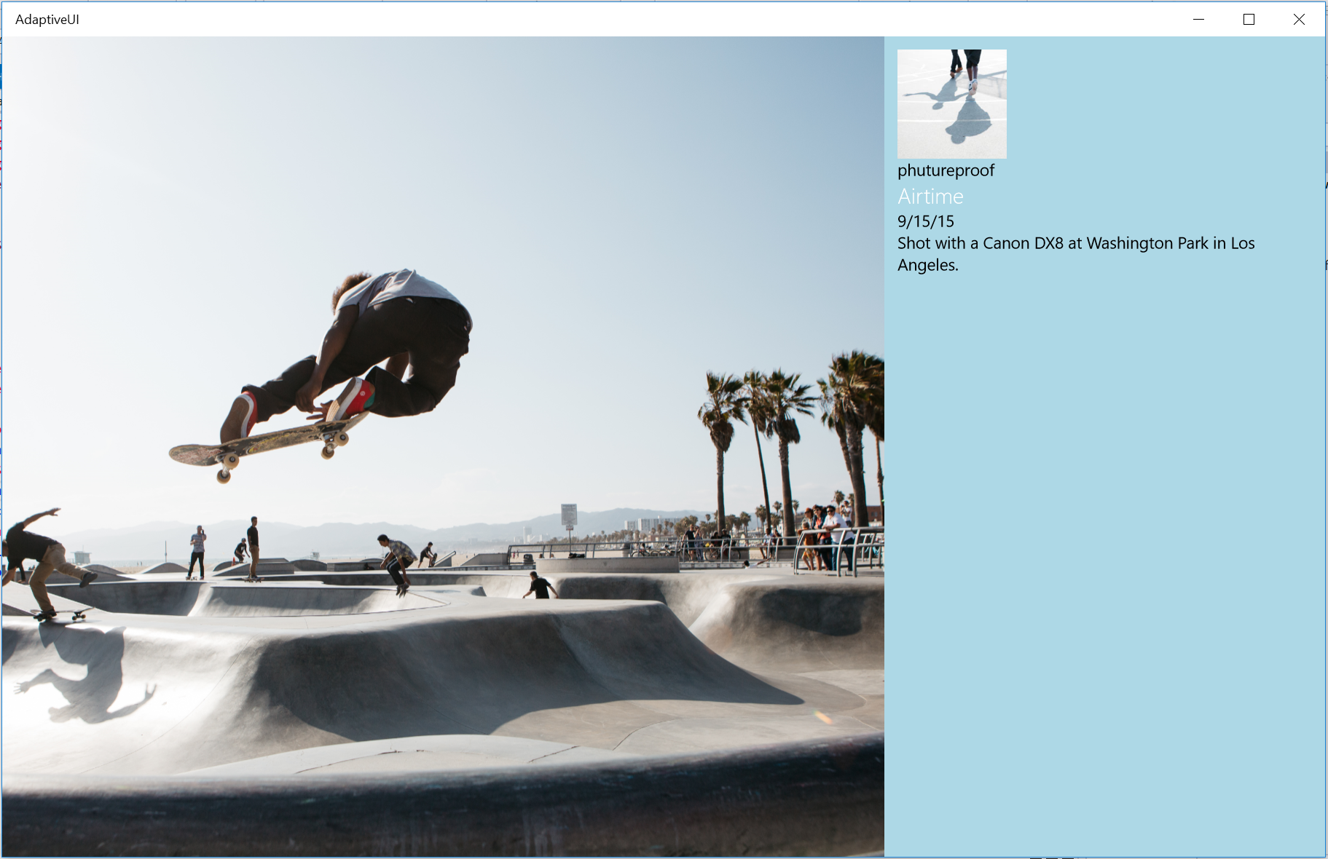 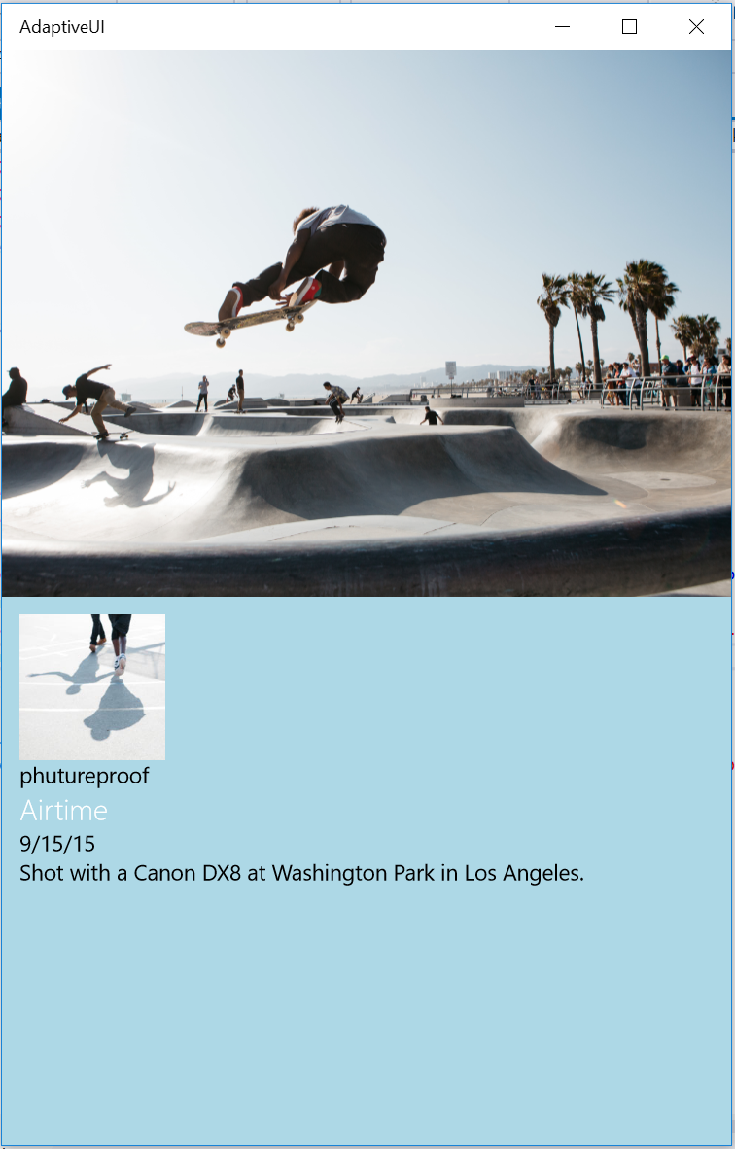

Figure 5

The metadata content moves below the image for smaller window sizes.

1. Stop debugging and return to Visual Studio.

Exercise 2: RelativePanels with Visual States

* 1. In this exercise, you will add a RelativePanel to handle semantically grouped content and further refine the responsiveness of the design.

Task 1 – Add the RelativePanel

The metadata content is grouped together in all states, which makes it a good candidate for a RelativePanel.

* 1. **Note:** A RelativePanel allows you define the layout of its children elements in relation to each other. While those relationships may stay the same across visual states, you may also modify them per state. For more on the RelativePanel, visit <https://msdn.microsoft.com/library/windows/apps/windows.ui.xaml.controls.relativepanel.aspx>

1. Change the Metadata **StackPanel** to a **RelativePanel** and keep its attributes the same.
   * 1. XAML
   1. <RelativePanel x:Name="Metadata" Background="LightBlue" Padding="12">
   2. <Image Source="Assets/avatar.jpg" Width="100" Height="100" HorizontalAlignment="Left" />
   3. <TextBlock Text="phutureproof" />
   4. <TextBlock Foreground="White" FontSize="20" FontWeight="Light" Text="Airtime" />
   5. <TextBlock Text="9/15/15" />
   6. <TextBlock Text="Shot with a Canon DX8 at Washington Park in Los Angeles." TextWrapping="WrapWholeWords" />
   7. </RelativePanel>
2. Enclose the image title, date, and description TextBlocks in a StackPanel. This information will remain stacked, and it will be easier to position the StackPanel than each item individually.
   * 1. XAML
   1. <RelativePanel x:Name="Metadata" Background="LightBlue" Padding="12">
   2. <Image Source="Assets/avatar.jpg" Width="100" Height="100" HorizontalAlignment="Left" />
   3. <TextBlock Text="phutureproof" />
   4. <StackPanel>
   5. <TextBlock Foreground="White" FontSize="20" FontWeight="Light" Text="Airtime" />
   6. <TextBlock Text="9/15/15" />
   7. <TextBlock Text="Shot with a Canon DX8 at Washington Park in Los Angeles." TextWrapping="WrapWholeWords" />
   8. </StackPanel>
   9. </RelativePanel>
3. Give **x:Name** attributes to the immediate children of the **RelativePanel**. These items will be positioned relative to each other.
   * 1. XAML
   1. <RelativePanel x:Name="Metadata" Background="LightBlue" Padding="12">
   2. <Image x:Name="Avatar" Source="Assets/avatar.jpg" Width="100" Height="100" HorizontalAlignment="Left" />
   3. <TextBlock x:Name="Username" Text="phutureproof" />
   4. <StackPanel x:Name="Description" >
   5. <TextBlock Foreground="White" FontSize="20" FontWeight="Light" Text="Airtime" />
   6. <TextBlock Text="9/15/15" />
   7. <TextBlock Text="Shot with a Canon DX8 at Washington Park in Los Angeles." TextWrapping="WrapWholeWords" />
   8. </StackPanel>
   9. </RelativePanel>
4. Use **RelativePanel.Below** and **RelativePanel.AlignHorizontalCenterWith** to position the username relative to the avatar. This relationship will stay the same across visual states.
   * 1. XAML
   1. <RelativePanel x:Name="Metadata" Background="LightBlue">
   2. <Image x:Name="Avatar" Source="Assets/avatar.jpg" Width="100" Height="100" HorizontalAlignment="Left" />
   3. <TextBlock x:Name="Username" RelativePanel.Below="Avatar" RelativePanel.AlignHorizontalCenterWith="Avatar" Text="phutureproof" />
   4. <StackPanel x:Name="Description" >
   5. <TextBlock Foreground="White" FontSize="20" FontWeight="Light" Text="Airtime" />
   6. <TextBlock Text="9/15/15" />
   7. <TextBlock Text="Shot with a Canon DX8 at Washington Park in Los Angeles." TextWrapping="WrapWholeWords" />
   8. </StackPanel>
   9. </RelativePanel>
5. Add visual state setters to target the placement of the description relative to the avatar. For the **VisualStateMin1024** and **VisualStateMin548** states, there is room to display the description to the right of the avatar. For the **VisualStateMin320** state, position the description below the avatar. The description margin will also need to adapt to its placement.
   * 1. XAML
   1. <VisualState x:Name="VisualStateMin320">
   2. <VisualState.StateTriggers>
   3. <AdaptiveTrigger MinWindowWidth="320"/>

</VisualState.StateTriggers>

* 1. <VisualState.Setters>
  2. <Setter Target="Hero.(Grid.ColumnSpan)" Value="2" />
  3. <Setter Target="Hero.(Grid.RowSpan)" Value="1" />
  4. <Setter Target="Metadata.(Grid.Column)" Value="0" />
  5. <Setter Target="Metadata.(Grid.Row)" Value="1" />
  6. <Setter Target="Metadata.(Grid.ColumnSpan)" Value="2" />
  7. <Setter Target="Metadata.(Grid.RowSpan)" Value="1" />
  8. <Setter Target="Description.(RelativePanel.RightOf)" Value="" />
  9. <Setter Target="Description.(RelativePanel.Below)" Value="Username" />
  10. <Setter Target="Description.Margin " Value="0,12,0,0" />
  11. </VisualState.Setters>
  12. </VisualState>
  13. <VisualState x:Name="VisualStateMin548">
  14. <VisualState.StateTriggers>
  15. <AdaptiveTrigger MinWindowWidth="548"/>
  16. </VisualState.StateTriggers>
  17. <VisualState.Setters>
  18. <Setter Target="Hero.(Grid.ColumnSpan)" Value="2" />
  19. <Setter Target="Hero.(Grid.RowSpan)" Value="1" />
  20. <Setter Target="Metadata.(Grid.Column)" Value="0" />
  21. <Setter Target="Metadata.(Grid.Row)" Value="1" />
  22. <Setter Target="Metadata.(Grid.ColumnSpan)" Value="2" />
  23. <Setter Target="Metadata.(Grid.RowSpan)" Value="1" />
  24. <Setter Target="Description.(RelativePanel.RightOf)" Value="Avatar" />
  25. <Setter Target="Description.(RelativePanel.Below)" Value="" />
  26. <Setter Target="Description.Margin " Value="12,0,0,0" />
  27. </VisualState.Setters>
  28. </VisualState>
  29. <VisualState x:Name="VisualStateMin1024">
  30. <VisualState.StateTriggers>
  31. <AdaptiveTrigger MinWindowWidth="1024"/>
  32. </VisualState.StateTriggers>
  33. <VisualState.Setters>
  34. <Setter Target="Hero.(Grid.ColumnSpan)" Value="1" />
  35. <Setter Target="Hero.(Grid.RowSpan)" Value="2" />
  36. <Setter Target="Metadata.(Grid.Column)" Value="1" />
  37. <Setter Target="Metadata.(Grid.Row)" Value="0" />
  38. <Setter Target="Metadata.(Grid.ColumnSpan)" Value="1" />
  39. <Setter Target="Metadata.(Grid.RowSpan)" Value="2" />
  40. <Setter Target="LeftCol.Width" Value="2*" />
  41. <Setter Target="RightCol.Width" Value="1*" />
  42. <Setter Target="Description.(RelativePanel.RightOf)" Value="Avatar" />
  43. <Setter Target="Description.(RelativePanel.Below)" Value="" />
  44. <Setter Target="Description.Margin " Value="12,0,0,0" />

</VisualState.Setters>

* 1. </VisualState>
  2. **Note:** In some visual states, the attached RelativePanel properties are set to empty string values. The empty string effectively erases the settings from the other visual states. Without these setters, some unwanted relative positions may persist across states.

1. In addition to making layout changes, visual state setters can redefine styles like font size and margin for better display on different devices. Remove the font attribute from the TextBlock representing the image name and add an **x:Name** directive to allow you to target that element.
   * 1. XAML
   1. <TextBlock x:Name="ImageName" Foreground="White" FontWeight="Light" Text="Airtime" />
2. Create setters to customize the font size based on the visual state.
   * 1. XAML
   1. <VisualState x:Name="VisualStateMin320">
   2. <VisualState.StateTriggers>
   3. <AdaptiveTrigger MinWindowWidth="320"/>

</VisualState.StateTriggers>

* 1. <VisualState.Setters>
  2. <Setter Target="Hero.(Grid.ColumnSpan)" Value="2" />
  3. <Setter Target="Hero.(Grid.RowSpan)" Value="1" />
  4. <Setter Target="Metadata.(Grid.Column)" Value="0" />
  5. <Setter Target="Metadata.(Grid.Row)" Value="1" />
  6. <Setter Target="Metadata.(Grid.ColumnSpan)" Value="2" />
  7. <Setter Target="Metadata.(Grid.RowSpan)" Value="1" />
  8. <Setter Target="Description.(RelativePanel.RightOf)" Value="" />
  9. <Setter Target="Description.(RelativePanel.Below)" Value="Username" />
  10. <Setter Target="Description.Margin " Value="0,12,0,0" />
  11. <Setter Target="ImageName.FontSize" Value="20" />
  12. </VisualState.Setters>
  13. </VisualState>
  14. <VisualState x:Name="VisualStateMin548">
  15. <VisualState.StateTriggers>
  16. <AdaptiveTrigger MinWindowWidth="548"/>
  17. </VisualState.StateTriggers>
  18. <VisualState.Setters>
  19. <Setter Target="Hero.(Grid.ColumnSpan)" Value="2" />
  20. <Setter Target="Hero.(Grid.RowSpan)" Value="1" />
  21. <Setter Target="Metadata.(Grid.Column)" Value="0" />
  22. <Setter Target="Metadata.(Grid.Row)" Value="1" />
  23. <Setter Target="Metadata.(Grid.ColumnSpan)" Value="2" />
  24. <Setter Target="Metadata.(Grid.RowSpan)" Value="1" />
  25. <Setter Target="Description.(RelativePanel.RightOf)" Value="Avatar" />
  26. <Setter Target="Description.(RelativePanel.Below)" Value="" />
  27. <Setter Target="Description.Margin " Value="12,0,0,0" />
  28. <Setter Target="ImageName.FontSize" Value="20" />
  29. </VisualState.Setters>
  30. </VisualState>
  31. <VisualState x:Name="VisualStateMin1024">
  32. <VisualState.StateTriggers>
  33. <AdaptiveTrigger MinWindowWidth="1024"/>
  34. </VisualState.StateTriggers>
  35. <VisualState.Setters>
  36. <Setter Target="Hero.(Grid.ColumnSpan)" Value="1" />
  37. <Setter Target="Hero.(Grid.RowSpan)" Value="2" />
  38. <Setter Target="Metadata.(Grid.Column)" Value="1" />
  39. <Setter Target="Metadata.(Grid.Row)" Value="0" />
  40. <Setter Target="Metadata.(Grid.ColumnSpan)" Value="1" />
  41. <Setter Target="Metadata.(Grid.RowSpan)" Value="2" />
  42. <Setter Target="LeftCol.Width" Value="2*" />
  43. <Setter Target="RightCol.Width" Value="1*" />
  44. <Setter Target="Description.(RelativePanel.RightOf)" Value="Avatar" />
  45. <Setter Target="Description.(RelativePanel.Below)" Value="" />
  46. <Setter Target="Description.Margin " Value="12,0,0,0" />
  47. <Setter Target="ImageName.FontSize" Value="24" />

</VisualState.Setters>

* 1. </VisualState>

1. Build and run your app. Resize through the snap points to observe how the layout of the RelativePanel changes.

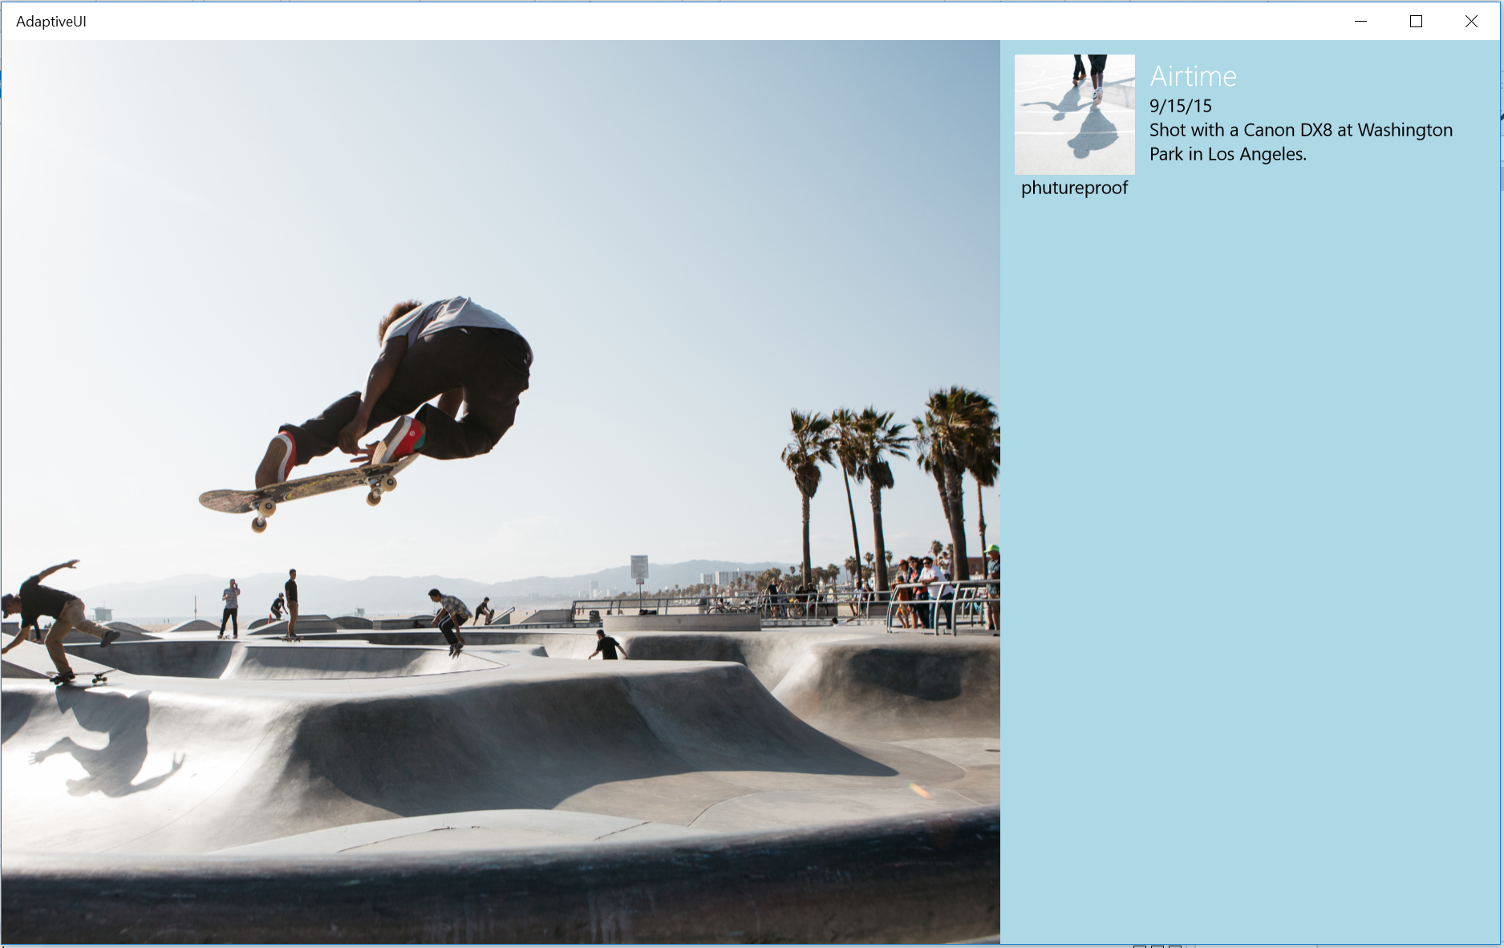

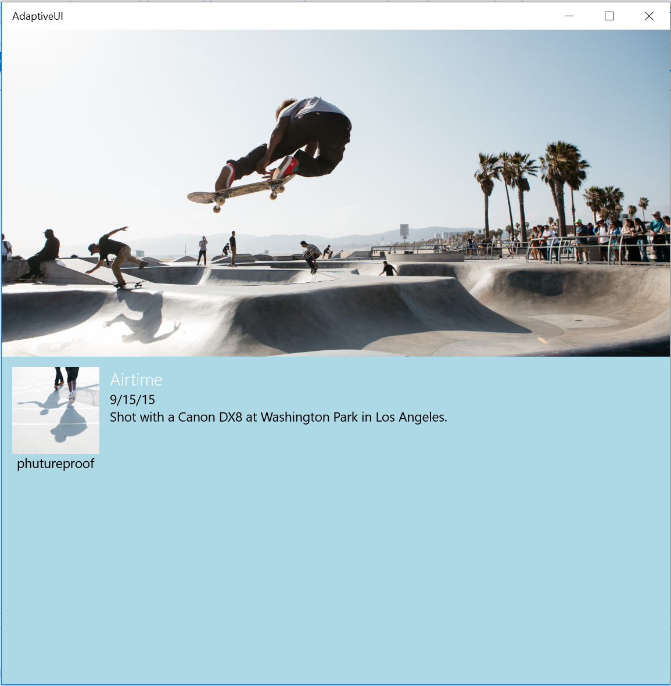 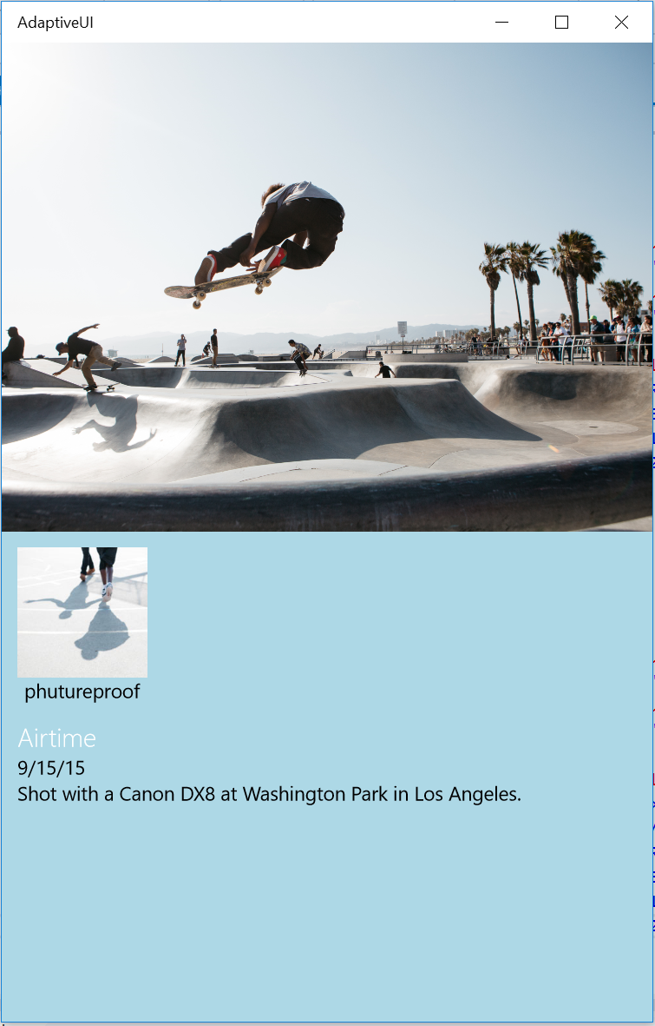

Figure 6

The RelativePanel content is repositioned for the different visual states.

1. Stop debugging and return to Visual Studio.

Exercise 3: Adaptive UI with XAML Views

* 1. In some cases, it’s not practical to adapt a UI responsively to different screen sizes, and it may be easier to start fresh with a separate view. XAML Views allow you to target specific device families with a unique view that uses the same code-behind as the original page. In this exercise, we will add scrolling behavior to the app and create a separate MainPage XAML View for Mobile to customize the experience.

Task 1 – Add a ScrollViewer to the Metadata panel

Before creating the new XAML view, let’s observe how a ScrollViewer will behave in the current MainPage.

1. Wrap the **Metadata** RelativePanel with a **ScrollViewer** and transfer the **Metadata** x:Name directive to the ScrollViewer.
   * 1. XAML
   1. <ScrollViewer x:Name="Metadata" VerticalScrollBarVisibility="Auto">
   2. <RelativePanel Background="LightBlue" Padding="12">
   3. <Image x:Name="Avatar" Source="Assets/avatar.jpg" Width="100" Height="100" HorizontalAlignment="Left" />
   4. <TextBlock x:Name="Username" Text="phutureproof" RelativePanel.Below="Avatar" RelativePanel.AlignHorizontalCenterWith="Avatar" />
   5. <StackPanel x:Name="Description">
   6. <TextBlock x:Name="ImageName" Foreground="White" FontWeight="Light" Text="Airtime" />
   7. <TextBlock Text="9/15/15" />
   8. <TextBlock Text="Shot with a Canon DX8 at Washington Park in Los Angeles." TextWrapping="WrapWholeWords" />
   9. </StackPanel>
   10. </RelativePanel>
   11. </ScrollViewer>
2. Copy a longer string into the image caption.
   * 1. XAML
   1. <TextBlock Text="Lorem ipsum dolor sit amet, consectetur adipiscing elit. Nulla imperdiet pulvinar nunc. In et gravida ipsum. Morbi congue consequat ullamcorper. Integer ornare porta convallis. Pellentesque habitant morbi tristique senectus et netus et malesuada fames ac turpis egestas. Vivamus sem nisi, ornare vel laoreet vel, accumsan facilisis tortor. Pellentesque ut nunc in leo vehicula pretium et at quam. Aliquam euismod id purus nec ultrices. Aliquam sed nisl at erat maximus finibus in sed urna. Nulla ullamcorper vehicula ex, in porta ante ullamcorper id. Phasellus a enim vitae odio ultricies semper. Suspendisse fermentum, erat in sodales accumsan, lacus urna aliquam nisi, sed ultricies dolor orci quis ligula." TextWrapping="WrapWholeWords" />
3. Build and run your app. Resize the app window to a height where the scroll bar appears. The scroll bar only appears on the metadata content, which means the second column scrolls in larger states and the second row scrolls in the smaller visual states.

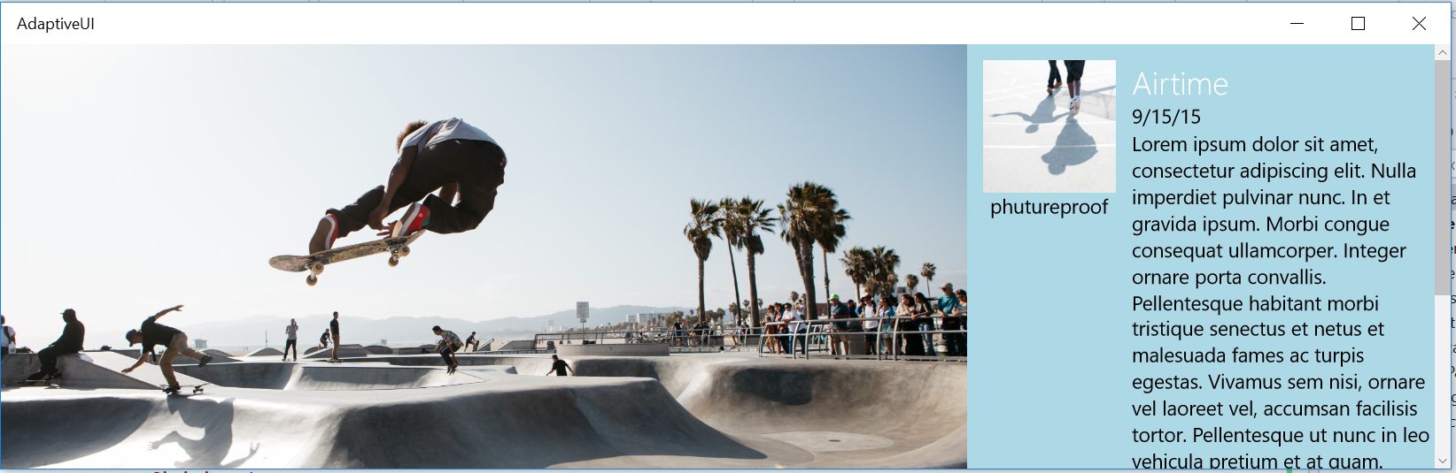

Figure 7

The Metadata scrolls while the hero image stays in place.

1. Stop debugging and return to Visual Studio.

Task 2 – Create a XAML view

The scroll behavior for smaller visual states is not ideal. It would be nice if the whole page scrolled on mobile devices. We could wrap the Grid in a ScrollViewer, but then the hero image would also scroll in larger visual states. In this task, we will create a separate view for Mobile to more finely control the scroll behavior without changing the behavior on desktop.

1. Right-click on the project name in the Solution Explorer and choose Add > New Folder. Give the folder the name **DeviceFamily-Mobile**.
   1. **Note:** The folder and views must be named precisely for XAML views to work. If you choose the folder route, the folders must be named **DeviceFamily-FamilyName** and the pages inside must share the same names as the original pages they replace.
   2. Alternatively, you can add files directly to the same folder as your original XAML pages and name them with the convention **OriginalPage.DeviceFamily-FamilyName.xaml**.
2. Right-click on the folder and use **Add > New Item** to add a **XAML View**. Give it the name **MainPage.xaml**.

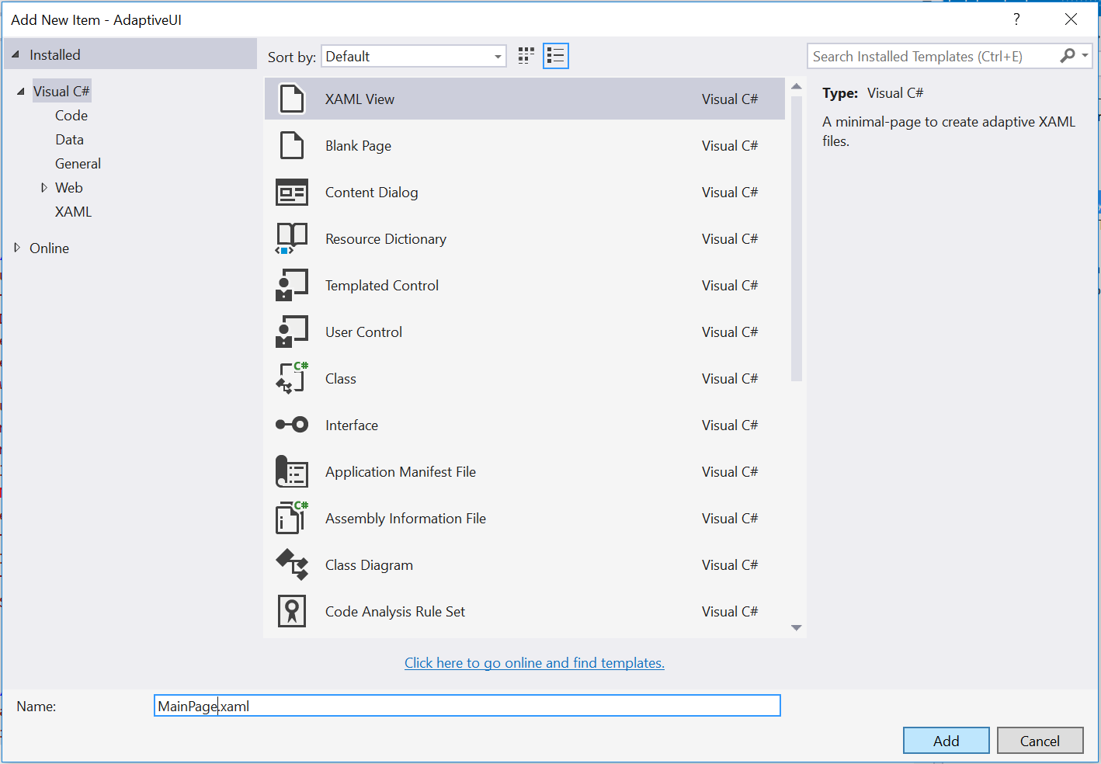

Figure 8

Add a XAML View.

* 1. **Note:** A XAML View is distinct from a Blank Page in that it will not generate a code-behind file. We wish to use the same MainPage.xaml.cs code behind for Mobile and Desktop, so we will create a XAML View instead of a Blank Page.

1. Copy the contents of your original **MainPage.xaml** into the new **MainPage.xaml**.
2. In the new **MainPage.xaml**, delete the all visual states and the VisualStateManager.
3. Return the **Metadata** **x:Name** attribute to the **RelativePanel** and move the **ScrollViewer** outside the Grid.
   * 1. XAML
   1. <ScrollViewer VerticalScrollBarVisibility="Auto">
   2. <Grid Background="{ThemeResource ApplicationPageBackgroundThemeBrush}">
   3. <VisualStateManager.VisualStateGroups>
   4. <VisualStateGroup x:Name="VisualStateGroup">
   5. <VisualState x:Name="VisualStateMin320">
   6. <VisualState.StateTriggers>
   7. <AdaptiveTrigger MinWindowWidth="320"/>
   8. </VisualState.StateTriggers>
   9. <VisualState.Setters>
   10. <Setter Target="Description.Margin" Value="0,12,0,0" />
   11. <Setter Target="ImageName.FontSize" Value="20" />
   12. </VisualState.Setters>
   13. </VisualState>
   14. </VisualStateGroup>
   15. </VisualStateManager.VisualStateGroups>
   16. <Grid.RowDefinitions>
   17. <RowDefinition />
   18. <RowDefinition />
   19. </Grid.RowDefinitions>
   20. <Image x:Name="Hero" Grid.Row="0" Source="Assets/airtime.jpg" Stretch="UniformToFill" HorizontalAlignment="Center" VerticalAlignment="Center" />
   21. <RelativePanel x:Name="Metadata" Background="LightBlue" Padding="12">
   22. <Image x:Name="Avatar" Source="Assets/avatar.jpg" Width="100" Height="100" HorizontalAlignment="Left" />
   23. <TextBlock x:Name="Username" Text="phutureproof" RelativePanel.Below="Avatar" RelativePanel.AlignHorizontalCenterWith="Avatar" />
   24. <StackPanel x:Name="Description" RelativePanel.Below="Username">
   25. <TextBlock x:Name="ImageName" Foreground="White" FontWeight="Light" Text="Airtime" />
   26. <TextBlock Text="9/15/15" />
   27. <TextBlock Text="Lorem ipsum dolor sit amet, consectetur adipiscing elit. Nulla imperdiet pulvinar nunc. In et gravida ipsum. Morbi congue consequat ullamcorper. Integer ornare porta convallis. Pellentesque habitant morbi tristique senectus et netus et malesuada fames ac turpis egestas. Vivamus sem nisi, ornare vel laoreet vel, accumsan facilisis tortor. Pellentesque ut nunc in leo vehicula pretium et at quam. Aliquam euismod id purus nec ultrices. Aliquam sed nisl at erat maximus finibus in sed urna. Nulla ullamcorper vehicula ex, in porta ante ullamcorper id. Phasellus a enim vitae odio ultricies semper. Suspendisse fermentum, erat in sodales accumsan, lacus urna aliquam nisi, sed ultricies dolor orci quis ligula." TextWrapping="WrapWholeWords" />
   28. </StackPanel>
   29. </RelativePanel>
   30. </Grid>
   31. </ScrollViewer>
4. Add the **Grid.Row** assignment to the **RelativePanel**.
   * 1. XAML
   1. <RelativePanel Grid.Row="1" x:Name="Metadata" Background="LightBlue">
5. Add the font size as an attribute to the **ImageName** element.
   * 1. XAML
   1. <TextBlock x:Name="ImageName" FontSize="20" Foreground="White" FontWeight="Light" Text="Airtime" />
6. Build and run your app on the Mobile emulator. We have chosen the Mobile Emulator 10.0.10240.0 WVGA 4 inch 1GB device. Click or tap on your content to see the scroll bar. Both the hero and the metadata will scroll.

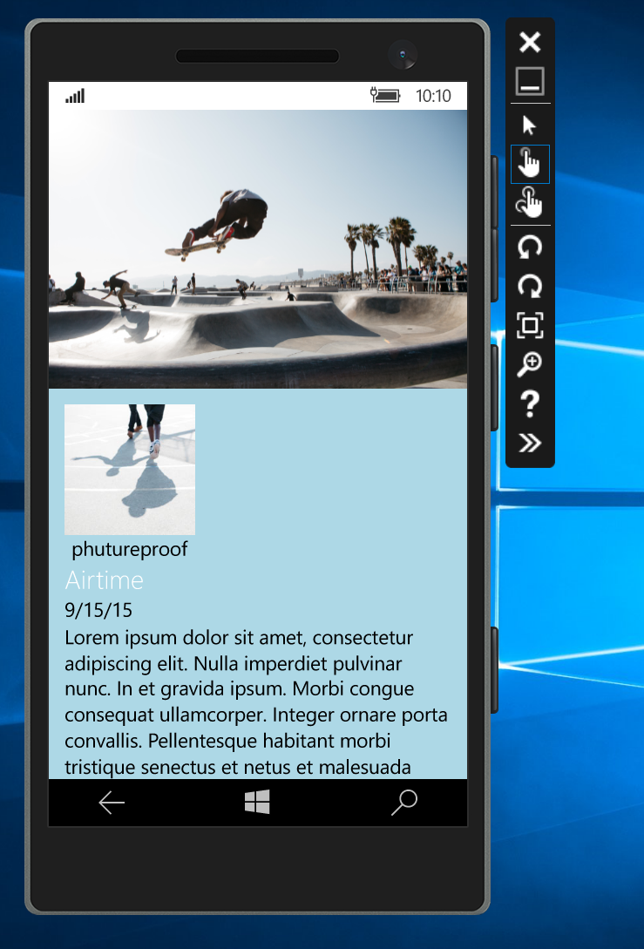

Figure 9

The adaptive Mobile view running on the emulator.

1. Stop debugging and return to Visual Studio.

Summary

* 1. Adaptive UI is a essential part of UWP app design. In this lab, we followed the principles of responsive design to reposition and reflow content to better suit smaller screens. We also created a separate view for Mobile to customize it beyond what can be done responsively.